A Timeless Archive: The Leeland Sudlow Collection- Documenting Decades of 4-H Activities
Written by: Brighton McBride

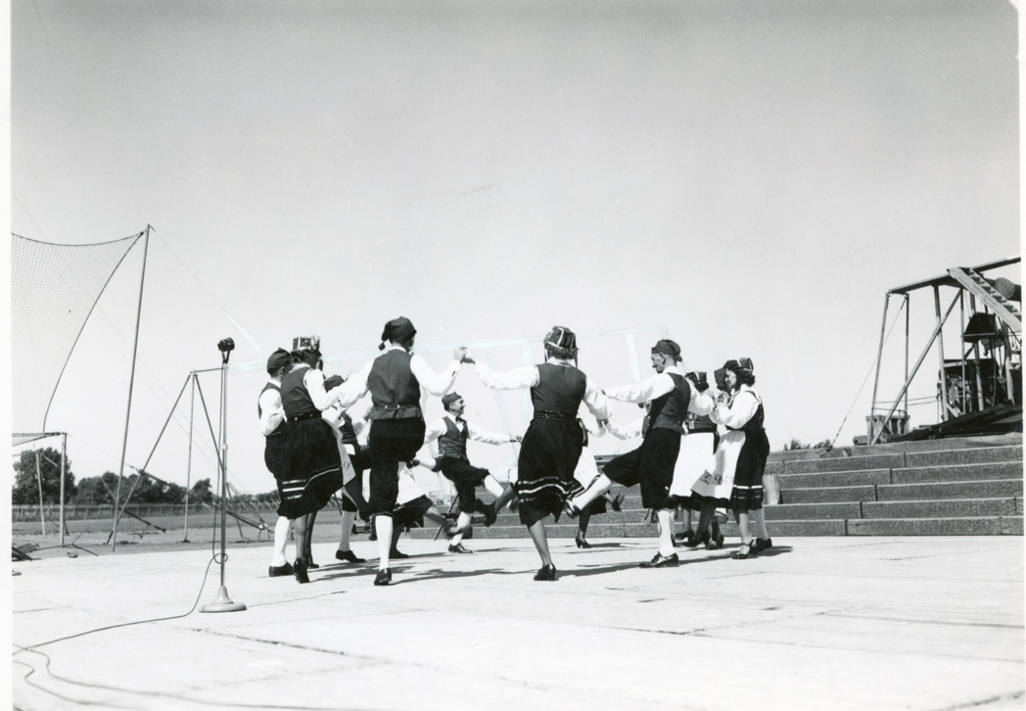
In an age where photographs are often digitized, shared, and forgotten in the scroll of social media feeds, there’s something particularly striking about a collection like the Sudlow Collection. A collection that spans decades, encapsulating both the timelessness and the evolution of a community. The Leeland Sudlow collection, consisting of over 34,000 photographs offers a rich visual history of 4-H activities and the extension movement in rural America. Through the lens of Sudlow’s camera, we can get a glimpse the transformation of agricultural practices, the dedication of youth to service and leadership, and the profound impact 4-H has had on generations of young people.
Sudlow 71-5-1 State Fair Folk Dances September 1947.
A Legacy in Photos
Leeland Sudlow, a passionate photographer and supporter of 4-H, captured a staggering array of images that document not just events, but the life and spirit of 4-H communities. These 34,000 photographs provide a unique perspective on the organization's activities and its role in local communities over the course of several decades. From county fairs to community service projects, from animal husbandry to the development of new agricultural techniques for crop production, Sudlow’s work spans the full spectrum of 4-H’s outreach, extension and educational programs.
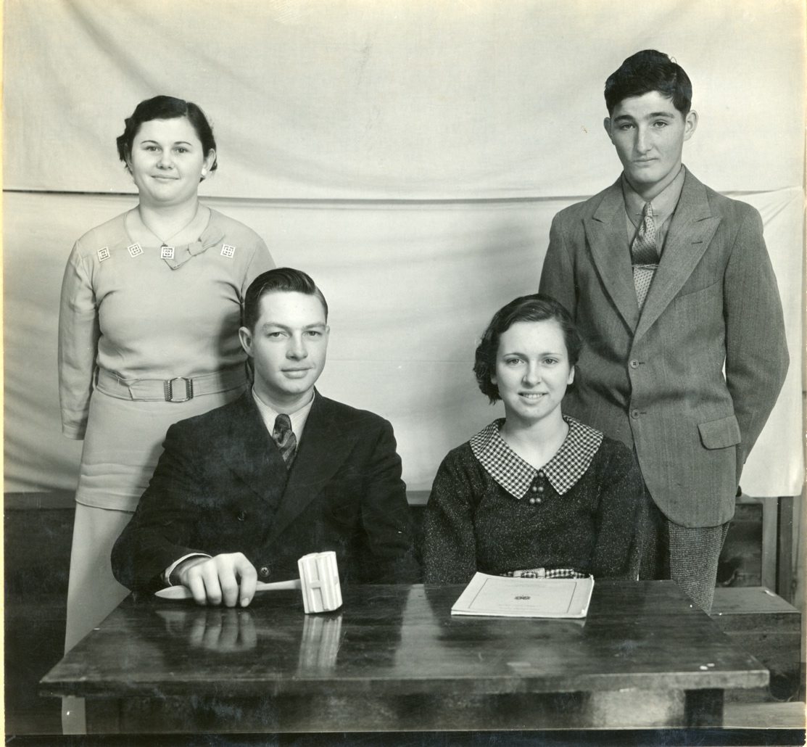
The photographs themselves are more than just images, they are records of a movement that has shaped and continues to shape rural America. Each photo is a testament to the dedication of youth who embraced the principles of 4-H: head, heart, hands, and health. Through Sudlow's lens, we can see the evolution of these principles in action, from the early days of 4-H clubs to the modern-day expansion of their mission.
Sudlow 84-4-4 1935 4-H Club officers
Faces of the Future: The Heart of 4-H
What makes the Leeland Sudlow collection so compelling is its focus on the people. The youth, families, and volunteers who brought the 4-H mission to life. Each photograph captures the joy, pride, and determination of the young people involved in 4-H, highlighting their accomplishments as well as their personal growth. Sudlow’s images convey the core values of 4-H: leadership, community, and hands-on learning.
In addition to 4-H members, many of the photos include volunteer leaders, county extension agents, local farmers and community supporters who worked tirelessly to guide and mentor youth. Through these portraits, we witness not only the success of individual 4-H members but also the collective effort that sustains the program year after year.
Sudlow’s photographs also document the impact of 4-H beyond the competition arena. The collection reflects the growing focus on service learning, an aspect of 4-H that encourages young people to engage with their communities and apply their skills in meaningful ways.
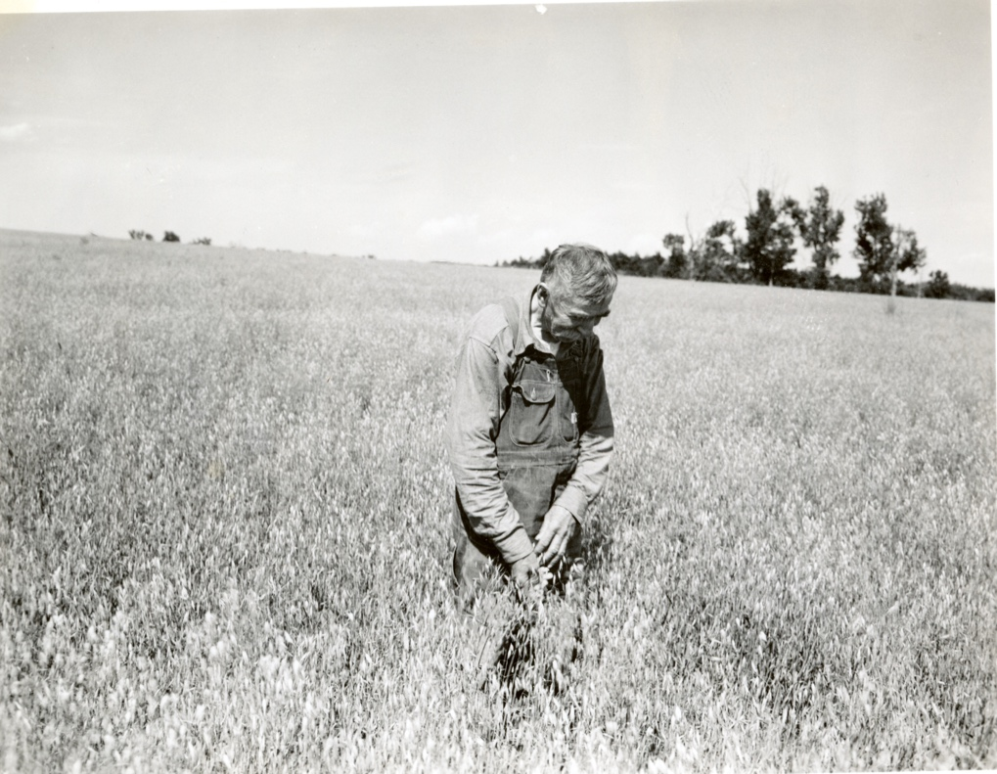
As the Agricultural Heritage Museum Collections Coordinator, Rachel Clendenin spoke about the collection. “A farmer is an everyman. They are the backbone of agriculture, and we don’t always have a face to go with them. This collection contains a unique cash that documents over 40 years of extension and 4-H.”
Sudlow 01-2-5 Kipps Farm McCook County. Taken July 11, 1941, Man is checking his Oats. Taken just months before the US entered WWII.
The Power of Photographs to Tell Stories
The Leeland Sudlow collection is more than a collection of photographs. It is a visual narrative of 4-H and its role in shaping the lives of rural youth across generations. As we look through these 34,000 images, we are not just seeing moments in time, we are witnessing the evolution of a movement that has empowered young people to become leaders, innovators, and active community members.

The South Dakota Agricultural Heritage Museum uses modern technology to digitize these photos to allow for a digital version. This process is tedious and takes time with attention from an employee, meaning it is not as simple or inexpensive as what we may imagine a scanner to be. The dedication the museum has to bringing these images to the public free of charge is truly remarkable. The museum greatly appreciates any and all donations to go toward the digitization of these images.

These photos remind us of the timeless values that 4-H instills in it’s members, values that continue to resonate today. As Sudlow’s images show us, the impact of 4-H is not just measured by ribbons and awards, but by the lasting impressions it leaves on the hearts and minds of those it touches. The collection is a celebration of these young people, their achievements, and the spirit of community that makes 4-H a cherished institution for generations to come.

